Email Subject Line: Painting Your Picture of Health

You are receiving this email because you are an FOH employee or an FOH agency point of contact. We also want our clients to receive the following message and would appreciate your help getting the word out. Please delete this opening paragraph and forward this email to FOH end users. Thank you!

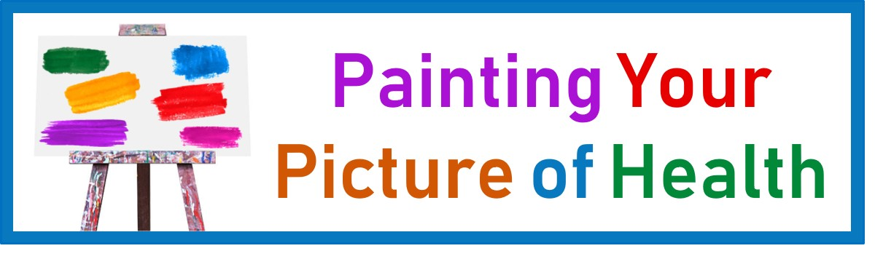

Wellness means something different to everyone, but there are some common actions we can all take to become our healthiest selves. Check out our tips and use them as paints and brushes to create your personalized picture of health. Mix and match, brush a lot or dab a little, stand back and admire, and repeat the process as needed!
Tips for Your Healthiest Self

