Facebook Post for Partners to Use to Promote the NAIP
The newly released National Adult Immunization Plan (NAIP) establishes four key goals around strengthening infrastructure, improving access, increasing community demand and fostering innovation to guide implementation of efforts aimed at optimizing the adult immunization system. View the NAIP and learn more about the many efforts underway to improve adult immunization: http://go.usa.gov/cEJq5

Facebook or Twitter Graphic for Partners to Use to Promote the NAIP

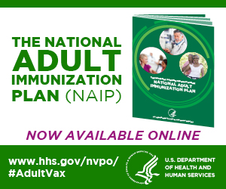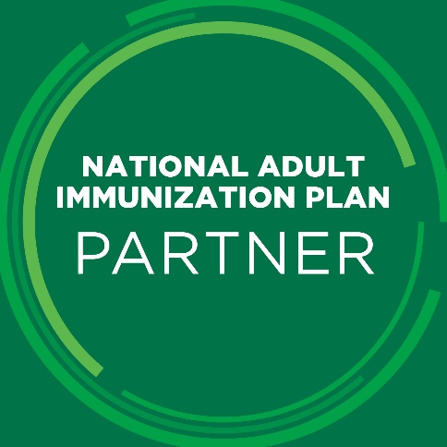

Tweets for Partners to Use to Promote the NAIP
Introducing the #NAIP, a plan for improving rates & infrastructure, to achieve optimal US #AdultVax system. http://go.usa.gov/cEJq5

New plan aims to strengthen infrastructure, improve access, increase demand & foster innovation of #AdultVax. #NAIP http://go.usa.gov/cEJq5

Twitter Background for Partners to Use to Promote the NAIP
