Quality Payment Program (QPP) – CJR Model Track Selection Reporting Instructions Summary

As of 2017 there are two participant Tracks in the CJR Model:
- Track 1, which is an Advanced APM; or Track 2, which is not an Advanced APM.

Track 1 of the Comprehensive Care for Joint Replacement (CJR) model is an Advanced Alternative Payment Model (APM) under the CMS Quality Payment Program.

CJR Participant Hospitals that elect to participate in Track 1 of CJR must use Certified Electronic Health Record Technology (CEHRT) as defined in 42 CFR 414.1305 to document and communicate clinical care to their patients or other health care providers. CJR Participant Hospitals electing Track 1 must attest to their CEHRT use as instructed below.

If the CJR Participant hospital does not choose a Track, that hospital will be considered as a Track 2 hospital, which is not an Advanced APM.

CEHRT Use Attestation:

42 CFR 510.120(a) states that each CJR Participant Hospital that elects Track 1 must attest to its use of CEHRT as defined in 42 CFR § 414.1305.

CJR model track selection and CEHRT use attestation for the purposes described above must be made on Tab 2 of the attached Excel document.

Financial Arrangements Reporting Instructions and Clinician Engagement List Reporting Instructions

In an effort to minimize burden to the extent possible, CMS combines the collection of information on participant hospitals’ track selection, financial arrangements, and clinician engagement. If a participant hospital chooses CEHRT use (Track 1), the CJR model team will use the information provided for financial arrangements for the clinician financial arrangement list. Also, if a participant hospital chooses CEHRT use (Track1), the participant hospital must submit, if applicable, a clinician engagement list. If there are no individuals that meet the requirements to be reported for a financial arrangement list or a clinician engagement list, the participant hospital must attest to CMS that there are no individuals to report. Please see instructions below for reporting.

Authority for Collection of Financial Arrangement Information and Clinician Engagement List:

To ensure all participant hospitals’ compliance with the requirements of the CJR model, under 42 CFR 510.110 participant hospitals must provide to CMS evidence sufficient to enable the audit, evaluation, inspection, or investigation of the individual’s or entity’s compliance with CJR requirements, the quality of services furnished, the obligation to repay any reconciliation payments owed to CMS, or the calculation, distribution, receipt, or recoupment of gainsharing payments, alignment payments, distribution payments, or downstream distribution payments. Therefore, when requested by CMS, each participant hospital must provide to CMS a list of previous and current collaborators, collaboration agents, and downstream collaboration agents.

Under 42 CFR 510.120(e), each participant hospital that chooses CEHRT use must maintain documentation of their attestation to CEHRT use, clinician financial arrangements lists, and clinician engagement lists. The participant hospital must retain and provide access to the required documentation in accordance with 42 CFR 510.110. Under 42 CFR 510.120(d) if there are no individuals that meet the requirements to be reported for a clinician financial arrangement list or a clinician engagement list, the participant hospital must attest in a form and manner required by CMS that there are no individuals to report.

Rather than requesting that participant hospitals submit three separate lists (both for monitoring and QPP purposes), CMS is directing hospitals to include all information requested for financial arrangements and clinician engagement in one Excel document.

The CJR model financial arrangements chart is included in Appendix A for reference.

Instructions for Completing the Excel Document

To reduce confusion, we established specific, detailed instructions for completing the attached Excel document.

Follow the instructions below:

Hospitals in Track 2- Not Attesting to CEHRT USE:

Hospitals in Track 2 and No Financial Arrangements Established
  - The participant hospital is in Track 2, the Non-Advanced APM Track for 2023.
  - The participant hospital has never executed any financial arrangements under the CJR model.

Next Step:
  - This hospital does not need to submit any documentation to CMS. If no documentation is submitted, CMS will consider the CJR participant hospital in Track 2 (Non-advanced APM) and no financial arrangements established for the CJR model.

Hospitals Selecting Track 2 and Financial Arrangements Established.
  - The participant hospital selects Track 2, the Non- Advanced APM track for 2023.
  - The participant hospital has executed financial arrangements under the CJR model, meaning a participant hospital has established a sharing arrangement with an eligible CJR collaborator for purposes of gainsharing under the CJR model.
  - If a CJR collaborator is an ACO, Physician Group Practice (PGP), Nonphysician Practitioner Group Practice (NPPGP), or Therapy Group Practice (TGP) then please confer with the entity to inquire whether they have executed any distribution arrangements with their respective ACO Participants or Members for purposes of distributing any gainsharing payment it receives from the participant hospital. For those ACO Participants or Members that executed a distribution arrangement with the applicable entity, these ACO Participants and/or Members are considered collaboration agents, whose information must be provided in this collection (Tab 4).
  - If an ACO Participant executed a downstream distribution arrangement with its Members, those Members are considered a downstream collaboration agent, whose information must be provided in this collection (Tab 5).

Next Steps:
- Complete Question 1, rows 2-13, Question 2, and Question 4 on Tab 2 of the Excel document.
- Sharing Arrangements- Provide all previous and current collaborators’ information on Tab 3.
  - This includes an ACO, PGP, NPPGP, TGP, Physician, Nonphysician Practitioner, Therapist in Private Practice, Skilled Nursing Facility, Home Health Agency, Long-term Care Hospital, Inpatient Rehabilitation Facility, Comprehensive Outpatient Rehabilitation Facility, Provider of Outpatient Therapy Services, Hospital, and Critical Access Hospital.
- Distribution Arrangements- Provide all previous and current collaboration agents’ information on Tab 4.
  - If the participant hospital established a sharing arrangement with an ACO, PGP, TGP, or NPPGP, but the ACO, PGP, TGP, or NPPGP has NOT established any distribution arrangements with its ACO Participants or Members, as applicable, do not complete Tab 4 of the Excel document.
  - If the participant hospital established a sharing arrangement with an ACO, PGP, TGP, or NPPGP, and the ACO, PGP, TGP, or NPPGP has established distribution arrangements with its ACO Participants or Members, as applicable, complete Tab 4 of the Excel document.
- Downstream Distribution Arrangement- Provide all current downstream collaboration agents’ information on Tab 5.
  - If the ACO established a distribution arrangement with an ACO Participant TGP, ACO Participant PGP, or ACO Participant NPPGP, but the ACO Participant TGP, ACO Participant PGP, or ACO Participant NPPGP has not established a downstream distribution arrangement with its respective Members, do not complete Tab 5 of the Excel document.
  - If the ACO has established a distribution arrangement with an ACO Participant TGP, ACO Participant PGP, or ACO Participant NPPGP, and the ACO Participant TGP, ACO Participant PGP, or ACO Participant NPPGP has established a downstream distribution arrangement with its respective Members, complete Tab 5 of the Excel document.

Hospitals Selecting Track 1- Attesting to CEHRT USE:

Hospitals Selecting Track 1 Participation and No Financial Arrangements established.
- The participant hospital selects Track 1 in the CJR model as an Advanced APM for 2023. The participant hospital attests to its use of CEHRT as defined in 42
CFR 414.1305 to document and communicate clinical care with patients and other health professionals.
- The participant hospital has never executed any financial arrangements under the CJR model.

Next Steps:
- Complete the following on Tab 2:
  - Question 1 only- “Participant Hospital Legal Name” and “Participant Hospital’s CCN.”
  - Questions 2, 3, 4, and 9.

- Clinician Engagement List (Tab 2-Question 9; Tab 6)
  - Each participant hospital that chooses Track 1 must submit, when applicable, to CMS a clinician engagement list. This list must include information on individuals for the 2023 performance year for each physician, nonphysician practitioner, or therapist who is not a CJR collaborator during the 2023 performance but who does have a contractual relationship with the participant hospital based at least in part on supporting the participant hospital's quality or cost goals under the CJR model during the 2023 performance year.
  - If the participant hospital has qualifying clinicians to report, answer Yes to Question 9, and provide the required information on Tab 6.

Hospitals Selecting Track 1 Participation and Financial Arrangements established.
- The participant hospital selects Track 1 in the CJR model as an Advanced APM for 2023. The participant hospital attests to its use of CEHRT as defined in 42 CFR 414.1305 to document and communicate clinical care with patients and other health professionals.
- The participant hospital has executed financial arrangements under the CJR model, meaning a participant hospital has established a sharing arrangement with an eligible CJR collaborator for purposes of gainsharing under the CJR model.
- If a CJR collaborator is an ACO, Physician Group Practice (PGP), Nonphysician Practitioner Group Practice (NPPGP), or Therapy Group Practice (TGP) then please confer with the entity to inquire whether they have executed any distribution arrangements with its ACO Participants or Members for purposes of distributing any gainsharing payment it receives from the participant hospital. For those ACO Participants or Members that executed a distribution arrangement with the applicable entity, these ACO Participants and/or Members are considered collaboration agents, whose information should be provided in this collection (Tab 4).
- If an ACO Participant executed a downstream distribution arrangement with its Members, those Members are considered a downstream collaboration agent, whose information must be provided in this collection (Tab 5).

Next Steps:
- Complete all questions on tab 2 of the Excel document.
- Sharing Arrangements- Provide ALL previous and current collaborators’ information on Tab 3.
  - This includes an ACO, PGP, NPPGP, TGP, Physician, Nonphysician Practitioner, Therapist in Private Practice, skilled nursing facility, home health agency, long-term care hospital, inpatient rehabilitation facility, Comprehensive Outpatient Rehabilitation Facility, Provider of outpatient therapy services, Hospital, and Critical Access Hospital.
- Distribution Arrangements- Provide all previous and current collaboration agents’ information on Tab 4.
  - If the participant hospital established a sharing arrangement with an ACO, PGP, TGP, or NPPGP, but the ACO, PGP, TGP, or NPPGP has NOT established any distribution arrangements with its ACO Participants or Members, as applicable, do not complete Tab 4 of the Excel document.
  - If the participant hospital established a sharing arrangement with an ACO, PGP, TGP, or NPPGP, and the ACO, PGP, TGP, or NPPGP has established distribution arrangements with its ACO Participants or Members, as applicable, complete Tab 4 of the Excel document.
- Downstream Distribution Arrangement- Provide all current downstream collaboration agents’ information on Tab 5.
  - If the ACO established a distribution arrangement with an ACO Participant TGP, ACO Participant PGP, or ACO Participant NPPGP, but the ACO Participant TGP, ACO Participant PGP, or ACO Participant NPPGP has not established a downstream distribution arrangement with its respective Members, do not complete Tab 5 of the Excel document.
  - If the ACO has established a distribution arrangement with an ACO Participant TGP, ACO Participant PGP, or ACO Participant NPPGP, and the ACO Participant TGP, ACO Participant PGP, or ACO Participant NPPGP has established a downstream distribution arrangement with its respective Members, complete Tab 5 of the Excel document.

- Clinician Engagement List (Tab 2-Question 9; Tab 6)
  - Each participant hospital that chooses CEHRT must submit, when applicable, to CMS a clinician engagement list. This list must include information on individuals for the 2023 performance year for each physician, nonphysician practitioner, or therapist who is not a CJR collaborator during the 2023 performance but who does have a contractual relationship with the participant hospital based at least in part on supporting the participant hospital's quality or cost goals under the CJR model during the 2023.
  - If the participant hospital has qualifying clinicians to report, answer Yes to Question 9, and provide the required information on Tab 6 of the excel document.

Submission Instructions- How and When to Submit

Participant hospitals must submit the completed excel document to CMS by uploading the document to the CJR Data Portal for their respective CCN. Please see the PPT file attached to the email titled, CJR Data Portal Upload Files Instructions.

For questions regarding access to the CJR Data Portal, please email CJRSupport@cms.hhs.gov and instructions will be provided. Please note, when uploading documents to the CJR Portal, spaces cannot be included in the document name.

After submission, the CJR model team will notify the participant hospital if the submission was correct or if any issues were identified and resubmission is necessary.

The deadline for submission is March 31, 2023, at 11:59PM EST.

Please contact the CJR model team at CJRSupport@cms.hhs.gov for questions concerning submission.
Appendix A:

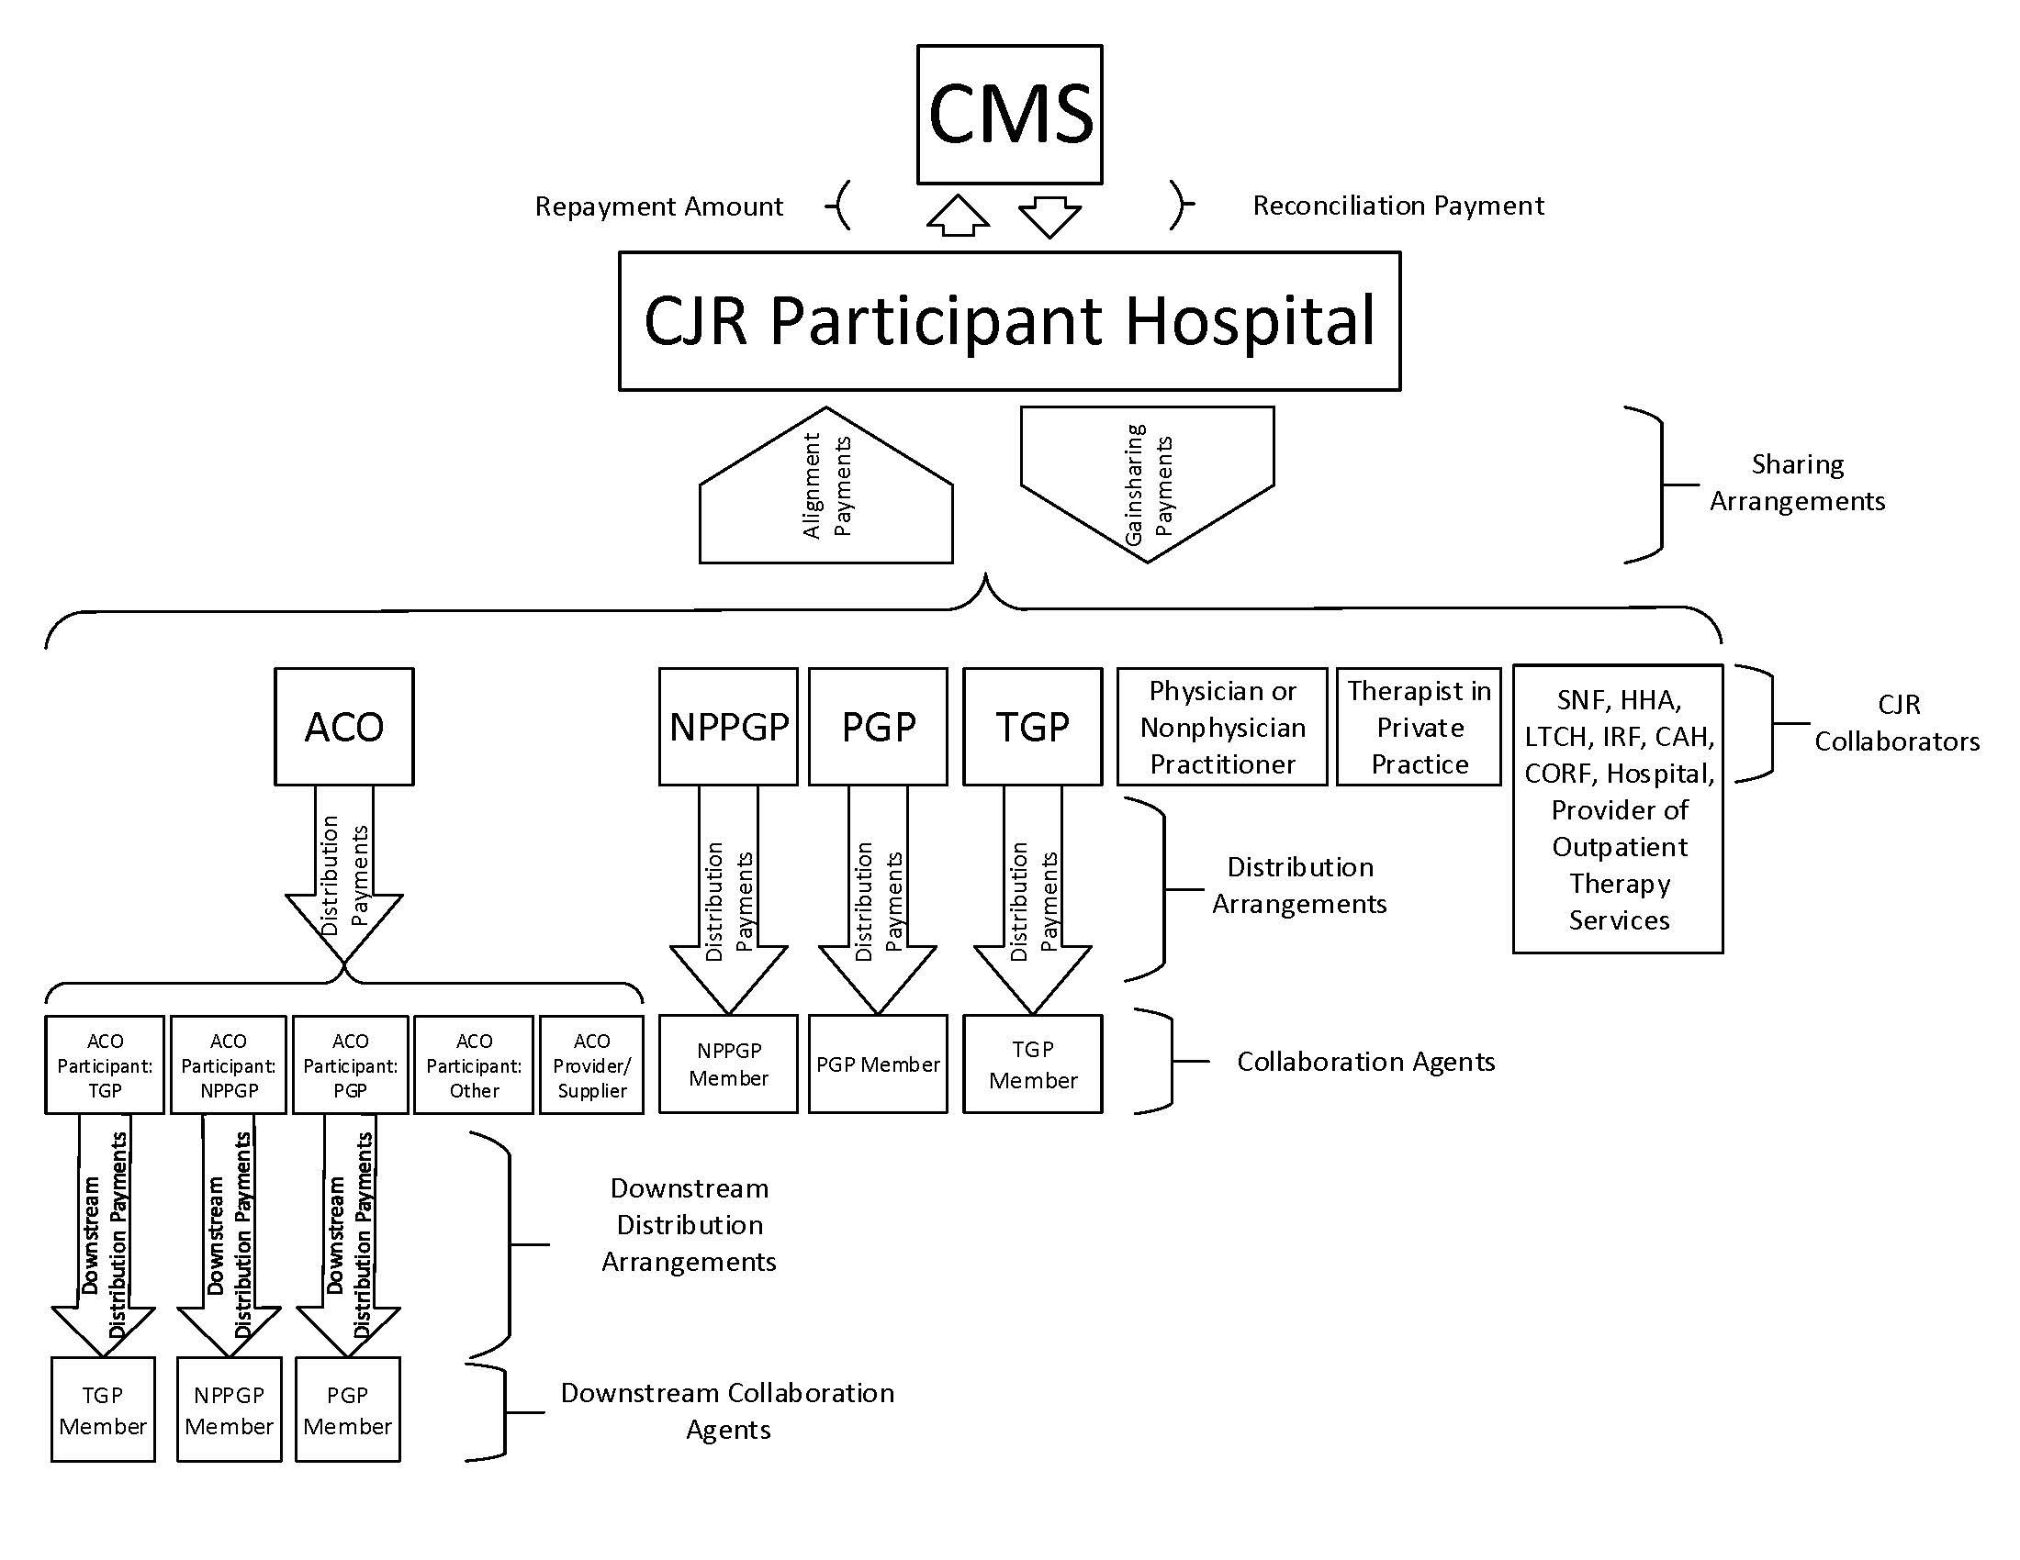

See the Advancing Care Coordination through Episode Payment Models final rule (81 FR 50794), available at https://www.gpo.gov/fdsys/pkg/FR-2017-01-03/pdf/2016-30746.pdf
More information about the Quality Payment Program is available at http://qpp.cms.gov/
42 CFR 510.120(a)
42 CFR 510.120(c)

